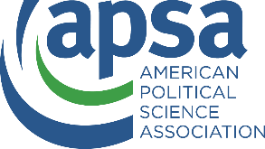
APSA Doctoral Dissertation Research Improvement Grant Budget Modification Request
Budget modification request forms should be filled out in all instances where the adjustments to the budget are equal to or more than 10% of the overall budget. Such adjustments include but are not limited to adjusting expenditures between budget categories and significant changes to the planned expenditure timeline. APSA reserves the right to deny grant modification requests. In addition to filling out this form, please submit an updated budget spreadsheet containing used and unused funds along with the original proposed budget.

Grantee Name: Click or tap here to enter text.
Project Title: Click or tap here to enter text.
Date: Click or tap to enter a date.
Email: Click or tap here to enter text.

Please explain each proposed adjustment from your original budget. Further justification or explanations may be requested prior to modification request approval. Notifications of approval, rejection, or needing further information will be sent via email.
Click or tap here to enter text.

